**Simpl Yourstory**

[yourstory.com](https://yourstory.com/2019/09/simpl-pay-later-payments-startup-fintech)

**How this Bengaluru startup is keeping it all Simpl by trying to make payments invisible**

Sampath Putrevu

6-8 minutes

Started by Chaitra Chidanand and Nityanand Sharma in 2016, Simpl is an additional credit wallet, which lets people make online purchases with one click and pay later.

Before banks and digital payments system came into use in India, people followed an offline wallet system, called the *‘Khaata System’* .Solely built on trust, everyone back in the day, be it the milkman or the shopkeeper, used it. The ownership of the offline wallet system was with the end-user and so followed convenience. The underlying intention for both the parties was that the commerce should happen without any friction and delay.

Similarly, in the USA, when credit or debit cards did not exist in the late 50s, people paid with cheques at shops if they did not carry enough cash. Chaitra Chidanand, Co-founder of Simpl, says,

"The system is still prevalent in many parts of the UK and Europe. Someone would send your home a bill, and at the end of the month, you balance your cheque book by clearing all the payments. This is also where you keep a track of all your purchases and expenses. It's like your own personal ledger."

However, with the rise of smartphones, the point of sale is now back with the user.

Spotting an opportunity to reinvent what payments could look like and put the power back in the customer's hands, **Chaitra Chidanand and Nityanand Sharma** **started Simpl in March 2016 in Bengaluru.** It is an additional credit wallet, which helps people make payments upfront on their purchases by paying the entire generated bill after a 20-day cycle.

However, **Simpl isn’t essentially a lending platform**, but only offers a **smoother checkout** mechanism.



Chaitra Chidanand

**Say no to credit cards**

An MBA graduate from Stanford University, Chaitra was previously working with Stanford Angels and entrepreneurs in the Silicon Valley before she moved to India.

According to Chaitra, while living in the US, she was told that her FICO score is very important to be able to live well and she needed to apply for a credit card soon. However, Nityanand Sharma, Co-founder, Simpl, and husband of one of Chaitra’s friends, did not want a credit card for the sake of having one.

With the high interest rates, Chaitra thought that taking a credit card otherwise would be the most expensive and financially irresponsible affair.

**"There is so much trust deficit and friction in the finance space in India. Banks lead their processes with mistrust, while every other business has the tab system. There are day jobs where people sit and collect payments and rents, and it all roots back to a fundamental lack of trust in the centralised institutions. But society operates on high levels of trust. That is the opportunity we saw. There are people who are worthy of being trusted and we needed to create a system where opportunism is minimised and value to people is maximised," Chaitra says.**

**How it works?**

Simpl gives the merchants its tech platform to be able to provide a frictionless buying experience for their customers.

The startup works on an open P&L (profit and loss) model with its merchants. With a ledger in the cloud that connects with the merchant's transactional system, using some data points provided by the merchant, Simpl underwrites its users using machine learning.

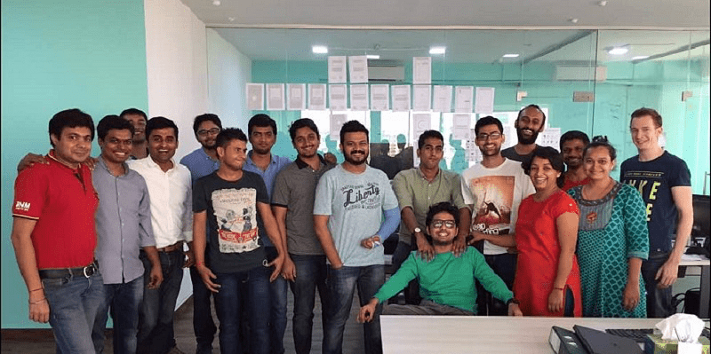

A Simpl team

However, when asked about incurring costs for Simpl, Chaitra refers to three of them – the working capital, the cost of default, and the cost of settlement. Essentially, the startup does whatever it can to move the needles further away from the user, where he/she has to settle from the bank accounts directly.

Subsequently, it takes away the cost of settlement from the user automatically. The startup uses machine learning in underwriting, fraud prevention, and payment collections.

Rishabh Bhagat, a student and a Simpl user, says,

“There are times when I'm low on cash or just don’t have much in my account, since I withdrew all of it. Simpl comes to rescue while ordering food, paying for recharges, and shopping.”

The startup, which has 95 employees, has humorously categorised its user base into four categories. **Diligent Deva** are the users who pay rents on time; **Freelance Freddy** is where students use the service and disappear during payments**, Broke Babu** are the young millennials who make the payments a month later with a late fee, and then there is **Lazy Lakshman** where users keep postponing the payments.

According to the team, this tells them on how to go about managing their operations better and efficient.

**Revenues and competition**

A white paper by ACI Worldwide along with AGS Transact Technologies (AGSTTL) says digital transactions in India can hit $1 trillion annually by 2025.

However, Simpl isn't the first startup in the credit space. **PayU's LazyPay** has been in the market since April 2017. In February last year, there was **Kissht**, which also launched the ‘Scan and Pay Later’ feature allowing users to shop on credit using its QR code.

At a time when merchant companies were busy building their own prepaid wallets, **what sets Simpl apart is that it aimed at providing a transparent financial system to everyone at the click of a button in real time, with no hidden charges.**

According to the company, it has achieved its unit economic profitability with a **28 percent revenue growth since inception**. **It has raised a total of $2.5 million in funding** from IA Ventures and Joseph Saunders, the ex-CEO of Visa. Over the years, the startup also claims to have seen 5x growth in terms of processed transactions.

With over five lakh downloads, the app is available both on Google Play Store and the App Store.

**Future plans**

With a surge to making payment experiences absolutely invisible, Chaitra believes that this innovation can be taken to the rest of the world.

She says, her investors in the US tell that the system makes sense even for their market, and there is no reason why American merchants have to pay two to three percent to Visa Mastercard just to process the transactions.

She humbly says,

"We did not reinvent anything, rather derived inspiration from the *Khaata System* that existed in the country forever."

***(Edited by Suman Singh and Megha Reddy)***

**[Product Roadmap] This fintech startup’s core lies in bringing 'Simpl'icity to payments using tech**

[yourstory.com](https://yourstory.com/2020/07/product-roadmap-fintech-startup-simplicity-simpl-payments)

Sindhu Kashyaap

7-9 minutes

In 2014, when **Chaitra Chidanand** returned to India from the US, she was dismayed to learn that she wasn’t eligible for a credit card as she had never paid taxes in the country, and didn’t have a permanent address either. To make matters worse, it took her eight weeks just to obtain a bank account and a debit card.

On the other hand, her husband’s friend **Nityananda Sharma**, who ran an advisory firm, also returned to Mumbai from New York at around the same time, and found that even his hedge fund experience couldn’t help him tackle the Indian banking system. It took him many application forms, a new fixed deposit, and multiple visits to the bank to get a platinum card.

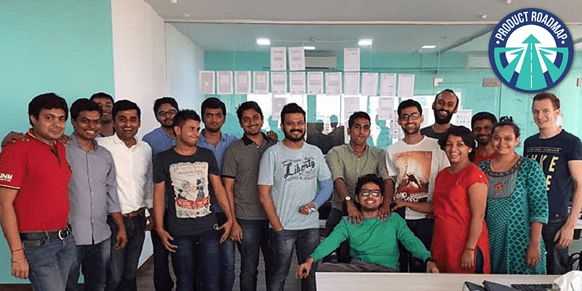

The Simpl team

Realising how complicated financial systems and products are in India, the duo launched Simpl in 2016. An online payment instrument, Bengaluru-based Simpl works as an additional credit wallet that allows a consumer to buy now and pay at a convenient time later.

**At the core of the product, the co-founders’ aim is clear — provide simple, transparent financial services to everyone using just a smartphone and one click of a button in real-time.**

**“**We work with merchants and financial institutions to enable a world where every monetary interaction is effortless and transparent. This helps online retailers give their consumers an exceptional checkout experience and post-transaction customer service,” says Nityananda, Co-founder and CEO of Simpl.

**The core systems**

**Simpl uses data, design, communication, and network for timely payments. The co-founder claims that the startup’s growth can be credited to its use of technology, data, and credit risk management, topped by lots of courage.**

The core system is built on polyglot microservices, largely of Ruby, GoLang, and Python. The startup leveraged AWS and its multi-AZ capabilities to provide for high availability. It also adopted a mix of open-source and homegrown tools for DevOps.

The co-founder explains that the platform offers a superior payment experience (industry-high success rates, time of transaction, and refund success), enabled by credit.

“We have a spectrum of users, from an average credit seeker to someone who values the convenience of our superior payment experience. Our users do not behave like typical borrowers, but it is imperative for us to safeguard our capital. This forces us to revisit conventional lending wisdom and develop a fresh understanding of capital management for credit-driven payments,” adds Nityananda.

**With AWS as the backbone, Simpl has built a lot of proprietary technology in-house. From serving a single merchant — cloud kitchen brand Faasos, owned by Rebel Foods — the startup now has over 1,000 partners.**

“To build the infrastructure to scale, we had to take a disciplined engineering and risk management approach. We were able to build better risk and underwriting models. We believe that our moat is deep, consisting of not only the merchant side integrations and proprietary data, but also of our models 'performance over time, and the learnings obtained by utilising them, which create immense barriers to entry for new participants,” says Nityananda.

**Using tech to minimise risk**

“In the early stages of the product, we had to keep reiterating and experimenting with data modelling. The [credit] limit for every customer is personalised to account for the risk, ability to pay, and their expected usage amount, which is based on transaction data, mobile data, etc,” says Nityananda.



Chaitra, Co-founder Simpl

Simpl has built an infrastructure with an advanced anti-fraud and underwriting model to scale its product. Through the invite-only nature, the platform attracts a positively-selected group of convenience seekers (rather than credit seekers) who constitute loyal and valued customers, creating an inherent risk mitigation framework.

“I was confident about the product, but my biggest surprise was how much users were loving it. I believe that UX/UI is the starting point for everything Simpl does. And we want to give the best user experience to our customers. We conducted a few feedback surveys, CSATs, etc., and gathered valuable inputs about specific user experiences. And it helped us to optimise the user onboarding on our website and app,” explains Nityananda.

**Harnessing the power of data**

**Data processing is integral to Simpl’s operations. Nityananda says that the platform receives millions of signals every day that to be processed, stored, and interpreted to enable credit decisions at scale.**

The platform’s data collection engine assembles structured and unstructured data from its network, which helps it predict customer behaviour. Various user touchpoints just dump data points into the event store, which are then parsed by various subsystems to glean the necessary ones asynchronously.

Utilising this proprietary data, the startup is uniquely positioned to enable merchants to offer personalised rewards to the right consumers directly and in real-time, says the co-founder.

Simpl’s affinity and credit models are based on machine learning (ML) algorithms. The startup had to open up its consumer funnel wide enough to be able to observe ‘bad behaviour’ that would equip the team to build anti-fraud systems and prevent ‘bad’ users from entering the system.

In addition to hindering adverse selection through its pre-approval process, Simpl has also removed any negative experiences for first-time users, who would otherwise be denied a line of credit.

For merchants, onboarding Simpl requires the integration of Simpl’s SDK (software development kit). From there, the company operates on a series of APIs (application programming interface) that let it remain lightweight.

“All this was being monitored closely and we kept updating the models. The first product was convenient enough for users. Of course, there were a few UI fixes and feature additions to improve the user experience,” says Nityananda.

**Challenges**

Building a multi-party marketplace from the ground up with an unproven business model is quite challenging. The hardest thing was to convince the first set of merchants to join the Simpl network.

After all, without an established precedent, why would anyone want to be the first node of an unproven network.

“We often joke that the first 10 merchants are impossible, the next 100 are very hard, but the next 10,000 are easy. On the consumer side, the same chicken-and-egg problem exists, but our merchant network has now reached a scale where it makes sense for us to aggressively grow the platform,” says Nityananda.

**The way forward**

**Today, Simpl competes with PayU’s LazyPay and Kissht’s ‘Scan and Pay Later**’. A white paper by ACI Worldwide along with AGS Transact Technologies (AGSTTL) says digital transactions in India can hit $1 trillion annually by 2025.

So far, Simpl has raised $2.5 million in funding from IA Ventures and Joseph Saunders, the former CEO of Visa. The startup claims to have seen 5X growth in terms of processed transactions, and the app itself has clocked close to five lakh downloads.

“We believe that the best payment experience is ‘no experience at all’, and the only experience that matters is of buying and enjoying the purchase. And, this has always been one of my legacy beliefs, which I never plan to let go,” adds Nityananda.